**Creating an executable jar file thru Eclipse**

**Step 1. Create Launch Configuration**

Objective: Choose a java file in your project that has a main() method to be intially launched when your jar file is clicked on. NOTE make sure to have your program working otherwise the jar will not be able to be created/run for our testing.

Right on your chosen java file and choose **Run As**>**Run Configurations...**

Go to your **Java Application** tree (expand it if necessary) and click once on your desired app name you wish to create an executable jar for. You should now see a new configuration is set for you to name! You are now ready to set up the Launch configuration.

Add in an appropriate Name for your Launch configuration where it says **Name**.

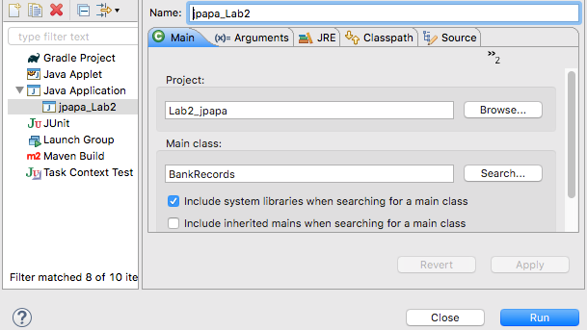

Leave all other defaults intact and check though the option to **Include system libraries when searching for a main class**.

Click Apply then Run.

Note, your Launch Configuration **name** has now been added as a configuration option located in your Java Application tree.

**Step 2. Export Runnable Jar file**

Now right click on your **project** in Eclipse and choose Export.

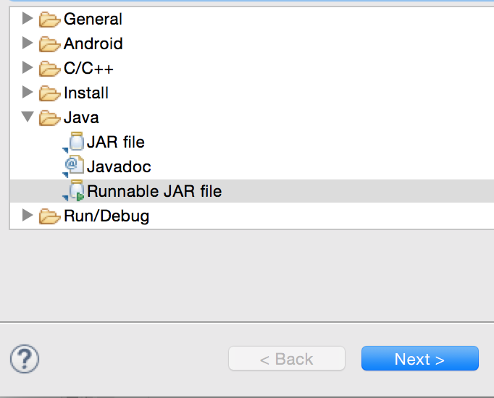

Drill down the Java folder and select Runnable JAR file. Select Next>.

Select your Launch configuration name from the pull down menu in the Runnable Jar File Specification dialog box with the launch confguration you *just* created. My name was call jpapa_Lab2.

Then select the path or Export destination for your desired jar. Please add the jar file location to be set into the path where your Lab 2 is (aka your project root folder). Name your export jar file appropriately ( in the pull down area under Export destination: ) Ex. your **first initial + first four letters of your last name + _Lab2** as your jar file name.

Keep all defaults, but make sure the option **Extract required libraries into generated JAR** is selected and press Finish. Snapshot follows…

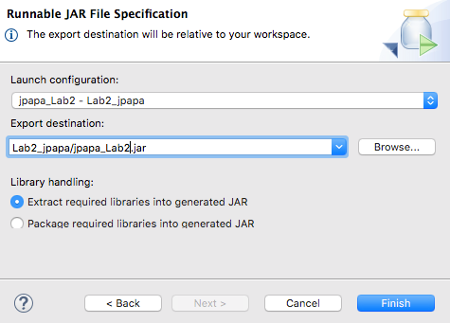

Press OK for any pop up dialog messages such as warnings or error messages to complete your mission.

Go to your jar file you just created within your desired path and run it. It should work. If not go back to the prior steps and check what went wrong. It could be trouble too if someone does not have the JRE installed on a given machine.

So you can now even simply zip your project folder for credit and it will automatically include your jar file! We put the jar file into your project folder that way when we run it to test your output, the jar file will be able to see your csv file in your project path, so your app runs successfully! Because this is a console based app, merely cliking on the jar file won’t execute anything visible. So to see it run, you would have to test it in a terminal or in DOS, etc.

Ex. of a run- type at a prompt, **java -jar yourJarFileName.jar**

